EXERCISE 15
1.List all employee ids and birth dates who were born before 1965.
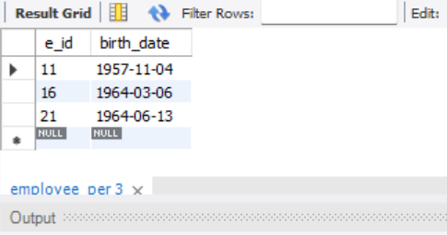

2. Display Ids and birthdates of employees born in and between 1970 and 1972.
